Experiment 5
Aim
To perform task analysis for an e-commerce application and design a user flow diagram that represents the steps a user follows while purchasing a product online.
Task Analysis
Task Analysis is the process of breaking down user interactions into smaller steps to understand how users complete a specific goal. In this experiment, the goal of the user is to successfully purchase a product through an ecommerce application.
This task analysis helps to:
• Understand user actions during online shopping.
• Identify decision points such as login and payment method.
• Improve the efficiency of the purchasing process.
• Reduce user confusion during checkout.
Key Aspects of Task Analysis
• Identifying user goal – Purchasing a product online.
• Understanding the sequence of actions from opening the app to order confirmation.
• Recognizing decision points (Login/Register, Payment Method).
• Ensuring smooth navigation between steps.
User Flow
User Flow is a visual representation of the path users take to complete a task within an application. In this design, the user flow represents the complete process of purchasing a product in an ecommerce application from start to end.
User Flow for E-Commerce Shopping System:
Start → Open App → Login/Register → Enter Username & Password → Login Successful → Home Screen → Browse Products → Select Category → View Product List → View Product Details → Add to Cart → Open Cart → Checkout Process → Enter Shipping Details → Select Payment Method → Payment Verification → Payment Success → Order Confirmation → Track Order → End
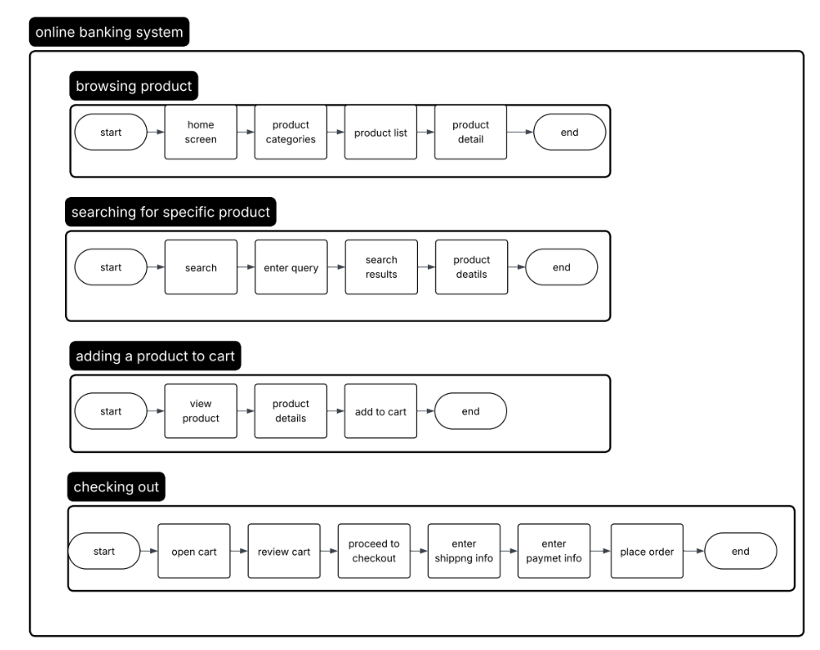
Step-by-Step Explanation of the System Flow
Step 1: Start
The user opens the online store application to begin shopping.
Step 2: Home Screen
After opening the application, the user lands on the home screen where different product categories and featured items are displayed. The user can browse products or use the search bar to find a specific item.
Step 3: Browse or Search Products
The user explores product categories or enters a keyword in the search bar. The system then displays a list of products related to the selected category or search query.
Step 4: View Product List
A list of available products appears with basic information such as product name, price, and a button to view more details.
Step 5: View Product Details
When the user selects a product, the system shows detailed information including product images, description, price, and key features.
Step 6: Add to Cart
If the user decides to purchase the product, they can add the item to the shopping cart. The cart temporarily stores the selected items.
Step 7: Open Cart and Review Items
The user opens the cart to check the selected products, review quantities, and confirm the total price.
Step 8: Proceed to Checkout
Once the user confirms the cart contents, they proceed to the checkout page to complete the purchase.
Step 9: Enter Shipping Information
The user provides delivery details such as their address, phone number, and preferred shipping option.
Step 10: Choose Payment Method
The user selects a payment option, such as credit/debit card, PayPal, or cash on delivery.
Step 11: Confirm Payment
If an online payment method is selected, the system processes and verifies the transaction before confirming the order.
Step 12: Order Confirmation
After successful payment, the system displays a confirmation message indicating that the order has been placed successfully.
Step 13: Track Order
The user can track the status of the order through the application until delivery.
Step 14: End
The online shopping process is completed successfully.
Decision Points in My Flowchart
• Login / Register decision
• Add to Cart decision
• Payment Method decision
• Payment Verification decision
These decision nodes allow flexible navigation and ensure smooth user interaction within the e-commerce system.
Result
The task analysis and user flow diagram were successfully created for the e-commerce application. The diagram clearly shows the sequence of steps and decision points involved in the online shopping process, from opening the application to tracking the order.

Wireframe:
